Course Project – Data Quality Dimensions

Shaun Pritchard

Rasmussen College

QMB4100

Darice Corey

April 22, 2021

Course Project – Data Quality Dimensions

**5 data dimensions.**

**Availability** – This is contingent on having the necessary data to create a functional user identity

To create and manage user identity, there has to be an authoritative source to provide the data. Allrecipes.com does have the availability of data. Allrecipes.com was one of the first teams to centralize and become a set of services for all Meredith organizations and incorporated sound BI practices and data extractions.

**Completeness** – requires that each data element is available in the system in the system? currently, 90% of the required data sources are available for users, interactions, advertisements, and recipes. Data will need to be omitted and collected during the onboarding process into the new product-service meal plans application. Missing data would consist of the personal user data, health data, dietary data, and personal goals the user aims to acquire with their customized meal plan.

**Accuracy** – Accurate data ensures that the transactions from the new product-service solution are based on the best possible representation of reality as it relates to the user. Currently, Allrecipes.com has become an integrated data-driven company with current BI practices and systems. The data accuracy should be on par with the objectives and requirements of this venture.

**Timeliness** – Timeliness ensures data is accessible when needed and is often dependent on the supporting specific management systems. Currently, the bulk of user and recipe data is accessible. The onboarding and survey testing data will need to be acquired and transformed.

**Consistency** – The ability to consume data and store it in the proper user attribute is dependent upon a common definition of data fields across the systems. For this dimension, establishing BI governance and organizational standards is key. Currently, Allrecipes.com has grown with the adopt BI a slice of surprising change within the company. It is reported by Vice President of Business Intelligence for Allrecipes.com that they have incorporated Sound business intelligence systems, tools, and infrastructure to facilitate consistency of data (Sarfin, 2020).

**Roles types and responsibilities**

**Data Trustee** - A data trustee is a senior administrator with significant responsibility for an operational area that uses a system/application serving as an authoritative source of data relied upon by the campus community.

**Responsibilities:**

* Manage, protect, and ensure the integrity and usefulness of data.
* Identify the sensitivity and criticality of the data. Ensure that appropriate business processes are in place to keep the data secure, maximize data accuracy, and ensure that responsible staff is trained to maintain data quality.
* Support planning and governance to meet the data needs of the Brown community.
* Work closely with the Vice President of business intelligence for Computing and Information Services and other members of the senior administration to ensure that the appropriate resources (staff, technical infrastructure, etc.) are dedicated to prioritizing data needs and setting/enforcing policies related to data management and use.
* Implement AllRecipes.com policies and ensure compliance with federal laws related to data governance.
* Serve as the escalation point for issues related to data governance.
* Designate data stewards.

**Data Steward** - A data steward is a staff member with oversight responsibility for a subset of the AllRecipes.com data. The steward is typically a functional end-user within an operational area who is deemed an expert regarding data managed by that operational area.

**Responsibilities:**

* Implement data standards.
* Ensure that staff who maintain data are trained to follow standards.
* Monitor data quality.
* Work with technical and operational staff to create a process for identifying data entry errors and correcting the data to match AllRecipes.com standards. Report to the data trustee any issues that may require larger action on behalf of the AllRecipes.com data governance structure.
* Handle inquiries about data.
* Receive and respond to any inquiries related to data that originates from the area they oversee, e.g., questions regarding access, standardization, organization, definition, and usage, etc.

**Data Custodian** - A data custodian is a system administrator or other technical professional who is responsible for some aspect of the management and operation of any of the systems that serve as sources of data.

**Responsibilities:**

* Provide a secure infrastructure in support of the data.
* This includes, but is not limited to, physical security, backup and recovery processes, and secure transmission of the data.
* Implement data access policies.
* Grant access privileges to authorized system users, documenting those with access and controlling the level of access to ensure that individuals have access only to that information for which they have been authorized and that access is removed in a timely fashion when no longer needed.
* Ensure system availability and adequate response time.
* Install, configure, patch, and upgrade hardware and software used for data management, ensuring that system availability and response time are maintained under AllRecipes.com policies and/or service level agreements.
* Participate in setting data governance priorities.
* Provide details on technical, systems, and staffing requirements related to data governance initiatives.

**Data User** - The data user is an individual who has access to AllRecipes.com data as part of assigned duties or in fulfillment of assigned roles or functions within the AllRecipes.com community.

**Responsibilities**

* Attend training and follow AllRecipes.com policies related to data management and protection.
* This includes policies and procedures regarding the security, integrity, quality, consistency, handling, and dissemination of AllRecipes.com data.
* Report concerns related to data management and protection.
* Convey to the appropriate AllRecipes.com administrator any observations or concerns about weaknesses in data protection, failure to follow data management policies or specific issues of quality or integrity of AllRecipes.com data.
* Basic usage of content and public data.

There are also other data governance roles and responsibilities based on the operating models of executive, enterprise, tactical level, and operational level depicted in the visual below that are contingent on the Allrecipes.com business model in data governance (TDAN, 2017).

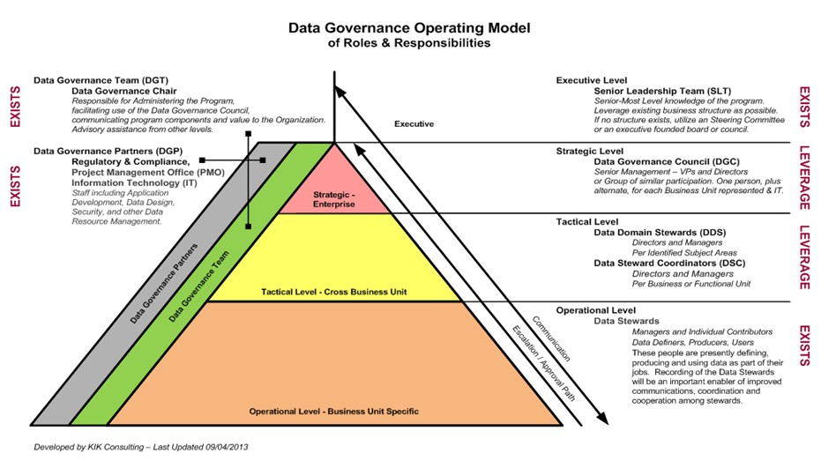

# References

Sarfin, R. L. (2020, Mar 7). *Data Quality Dimensions: How Do You Measure Up? (+ Downloadable Scorecard)*. Retrieved from https://www.precisely.com: https://www.precisely.com/blog/data-quality/data-quality-dimensions-measure

TDAN. (2017, June 21). *Complete Set of Data Governance Roles & Responsibilities*. Retrieved from https://tdan.com: https://tdan.com/complete-set-of-data-governance-roles-responsibilities/21589